Lab 6 CCS3104
2 January 2026
- Solve the following questions and demonstrate your solutions to me in this lab, the next lab or at the start of the lab after next. This is a 2-weeks lab. For record-keeping, also submit your solutions and screenshots of their output to PutraBlast.
- Evaluation will be done according to the lab rubric on PutraBlast. I will ask questions accordingly.
*******************************

Questions:

- Given the following slide in the Remote Method Invocation lecture slides:

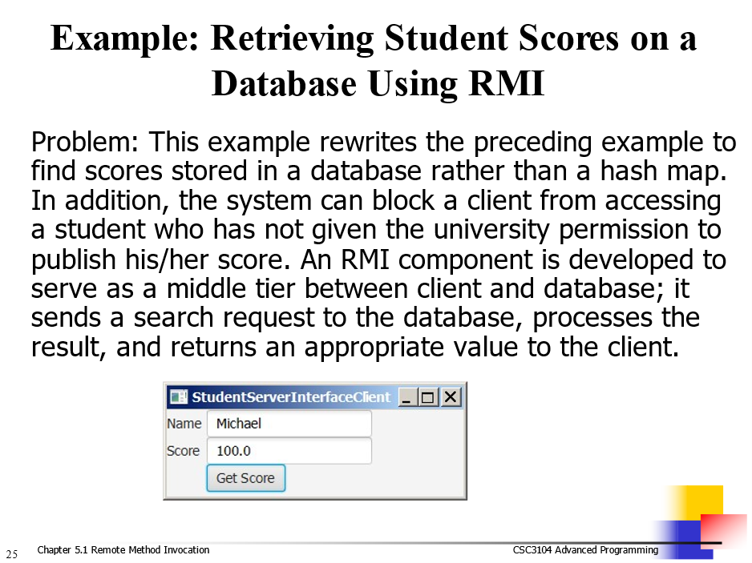

implement the above example using JavaFX, RMI and JDBC. You must use PreparedStatement for any SQL statements. Use the script on the next page to create the database:

connect 'jdbc:derby:javabook;create=true;user=scott;password=tiger';

drop table Scores;
create table Scores (name varchar(20),
score double, permission boolean);

insert into Scores values ('John', 90.5, true);
insert into Scores values ('Michael', 100, true);
insert into Scores values ('Michelle', 100, false);

commit;

